Dijkstra’s Shortest-Path Algorithm

Section 10.6 Page 709-714

Implement Dijkstra’s Shortest-Path Algorithm and use that program to solve the example in Figure 4 on Page 713.

The program should ask for the name of the file containing the graph. Read in that file and build tables representation the graph. The program should than ask for the starting vertex and the ending vertex. The program should implement Dijkstra’s Shortest-Path Algorithm to calculate the shortest-path. The program should print the path along with the length. Even though in Figure 4 all the vertices have a single character labels you should use a String to hold vertices names. By using a String your program can be used with the names of cities from a roadmap.

I have attached to this assignment the graph file for Figure 4, file name is Page713. The PowerPoint lecture for this section goes through the operation of Dijkstra’s Shortest-Path Algorithm’s for this example in detail.

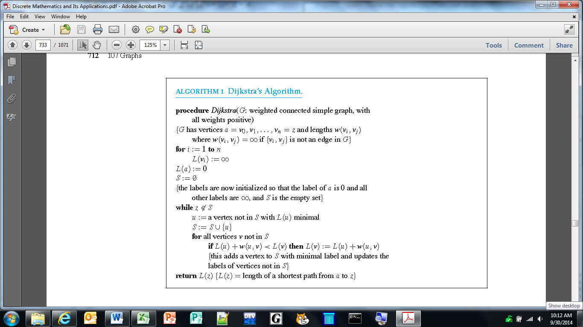

Below is the output from the program that I wrote in Java to implement Dijkstra’s Shortest-Path Algorithm.

The input for this program is:

a b 4
a c 2
b c 1
b d 5
c d 8
d e 2
d z 6
e z 3

The output should look like the following:

ÏÏ«Ï ----jGRASP exec: java ShortestPath
ÏÏ§Ï
¼¼§ÏEnter the filename: Page713
ÏÏ§Ï
ÏÏ§ÏThe edges of the graph
ÏÏ§Ï
ÏÏ§Ïa b 4
ÏÏ§Ïa c 2
ÏÏ§Ïb c 1
ÏÏ§Ïb d 5
ÏÏ§Ïc d 8
ÏÏ§Ïd e 2
ÏÏ§Ïd z 6
ÏÏ§Ïe z 3
ÏÏ§Ï
¼¼§ÏEnter the starting vertex: a
¼¼§ÏEnter the ending vertex: z
ÏÏ§Ï
ÏÏ§Ï13 (a, c, b, d, e, z)
ÏÏ§Ï
ÏÏ©Ï ----jGRASP: operation complete.

